Firmware V3.1.3

1：Solved Some Radio Call ID is not Displayed Properly

Software V3.1.1

Firmware V3.1.1

1：RX Group List - Contact 16 →Contact 32

2：RX Group List 128→ 76

3：ADD Scan Time Setting

4：VFO Bug Repair

V3.0.5

1：ADD VFO

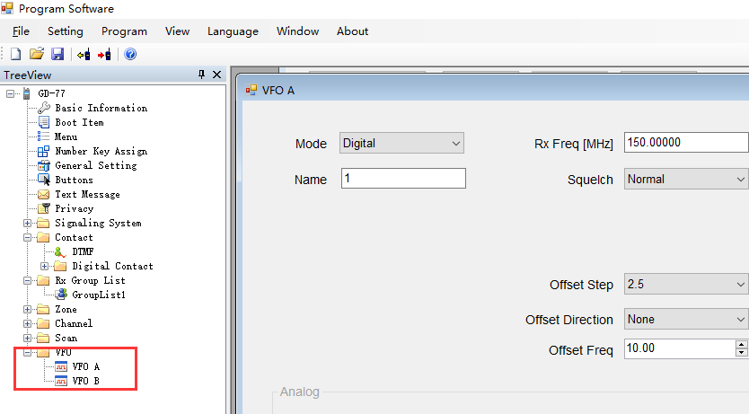

2：Contact ID 1000

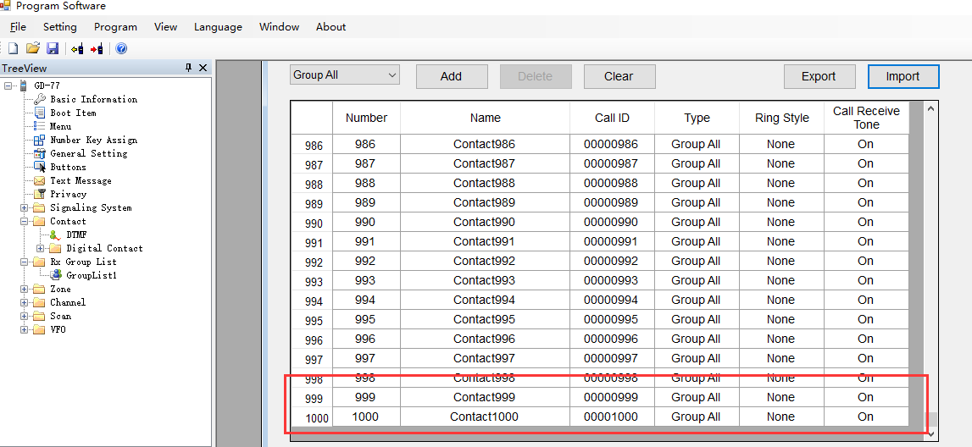

3: Scan list 64

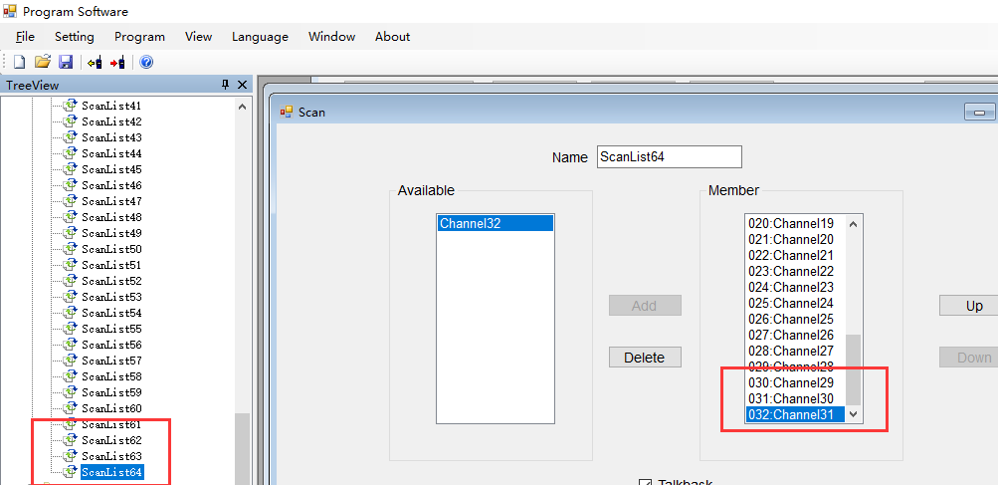

ADD DMR ID

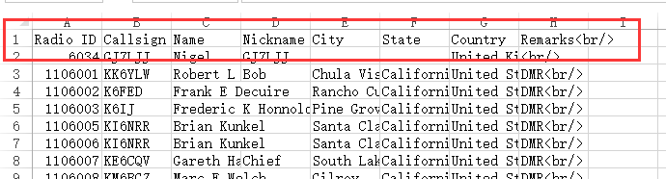

4：128 RX Group List

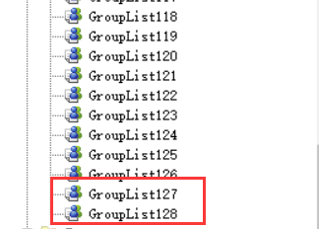

5：ZONE Abnormal Repair 。

6：2.5K step

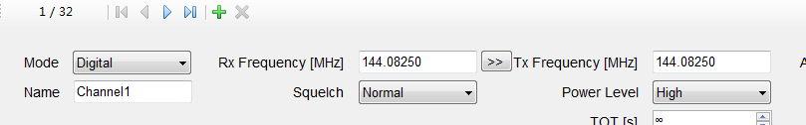

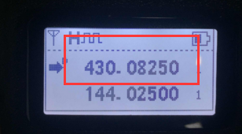

7:Europe Input Method CTCSS/DCS Save:

